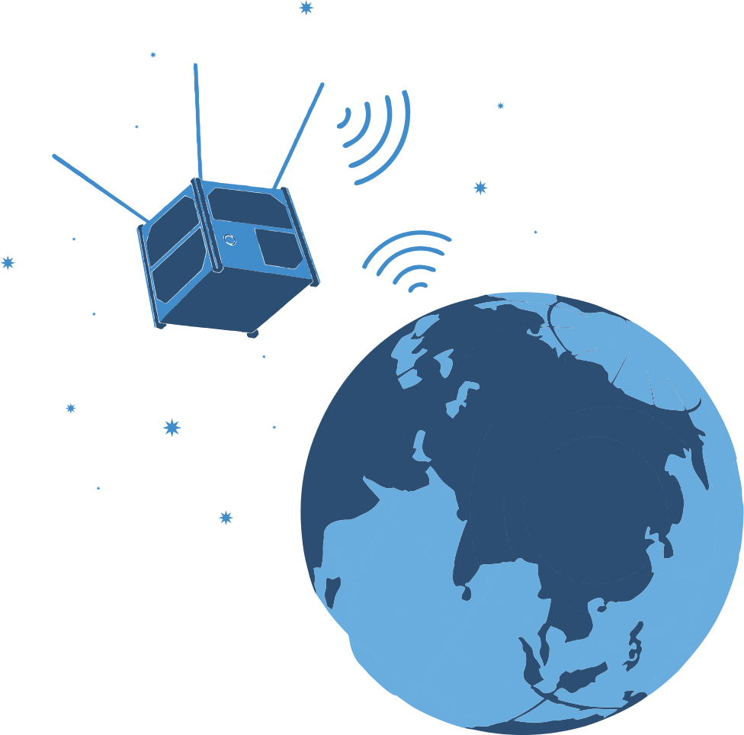

**Team name:**

**School name, number and address:**

**Team leader:**

**Contact number:**

**Student 1:**

**Student 2:**

**About CubeSats**

*(Explain the elements used in the model prepared here, the functions they perform, the design of the CubeSat, its dimensions, weight, etc., its advantages)*

**Wireless communication with CubeSat**

*(This should be a video of the model being prepared transmitting data wirelessly. The video link in YouTube format should be posted here for 60-90 seconds)*

**Team photo**

*(This should include a photo of all team members at work or in front of the drone)*

1. **Technical name and images of the elements used**
   1. Sensors (names and pictures)

*(If more than 1 sensor is used here, the name and picture of each should be listed separately)*

* 1. Main controller (name and picture)
  2. Wireless connection used (name and image)
  3. CubeSat fuselage design (image in design software)

**CubeSat photo images**

*(Here, the size should be visible with a ruler next to the model in each photo)*

* 1. From the left
  2. From the right
  3. From the front
  4. From behind
  5. From above
  6. From below

**Satellite Model Photo Images**

* 1. From the front
  2. From above