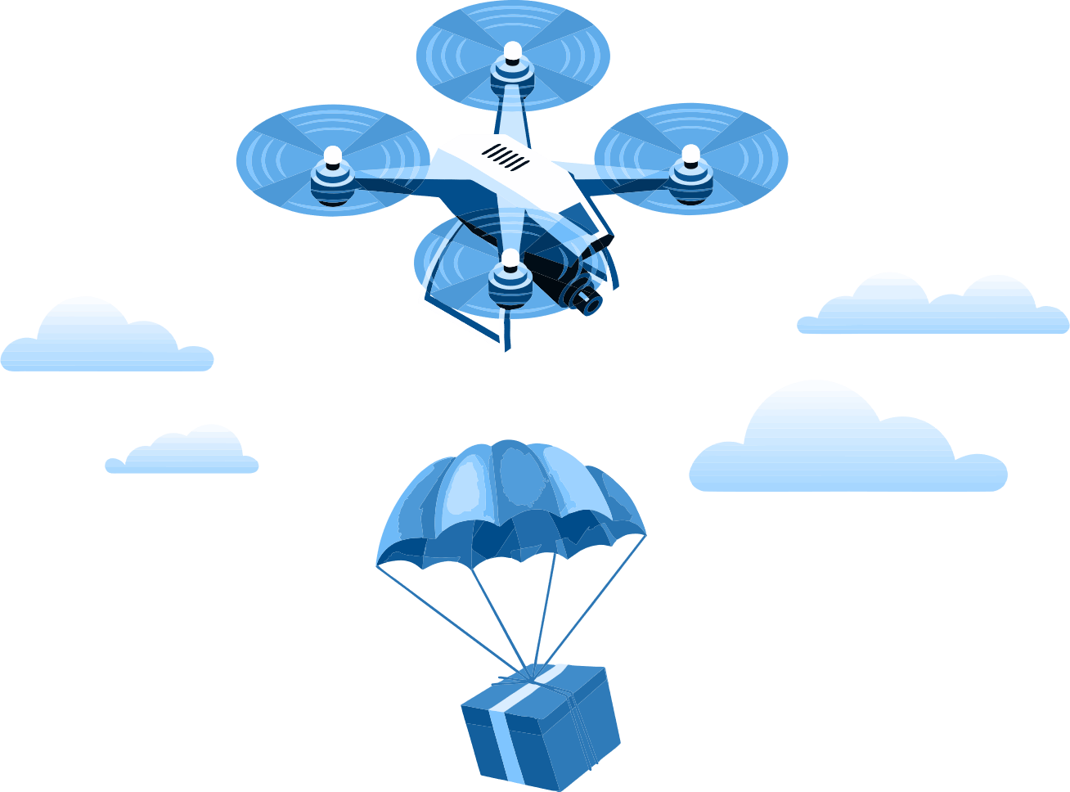

**Team name:   
  
  
School name, number and address:**

**Team leader:**

**Student 1 :**

**2nd student :**

**3rd student : (if any)**

1. **Drone feature**

*(Please explain the advantages of the drone you made, the body materials used, dimensions, weight, etc.)*

1. **Link to drone flight video**

*(must be video in Youtube format here)*

1. **Team photo**

*(This should include a photo of all team members at work or in front of the drone)*

1. **Technical name and images of the elements used**
   1. Engine (name and picture)
   2. Fan (name and picture)
   3. Electronic Speed Controller - ESC (name and picture)
   4. Battery (name and picture)
   5. Flight controller (name and picture)
   6. Wireless remote control (name and picture)
   7. Servo motor (name and picture)
   8. Camera (name and picture)
2. **Drone photos**
   1. From the left
   2. From the right
   3. From the front
   4. From behind
   5. From above