

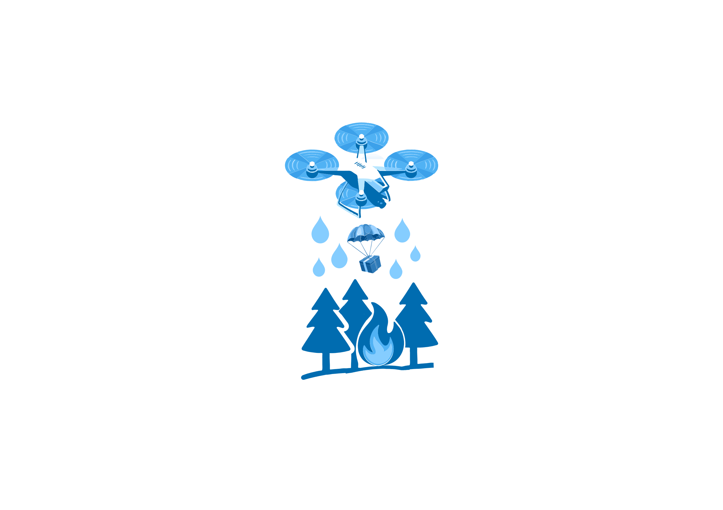

BAKU 2025

**FLYTECH**

**SELECTION STAGE RULES**

Selection stage rules

* 1. To participate in the competition, each team trades a presentation of their drone. In this competition, different ideas and thoughts play a big role in the development of the drone.
  2. **To participate in the selection and discuss, each team must prepare its drone according to the materials and dimensions provided in the competition rules.**
  3. After the registration for the competition was over, the selection date was announced. The teams that participated in the selection will compete in the Final stage. With this success, the teams qualified for the Final.
  4. The selection steps are as follows:
  5. The team's name, surname, school number, and position in the team.
  6. Drone Presentation, where the front, back, left, right, and top photos of the drone should be clearly arranged and each element used should be labeled with its name and purpose.
  7. The drone's payload release mechanism and control, as well as the technology for manufacturing the release mechanism, are explained.
  8. **Drone preparation – Must meet all requirements in the Final Rules!**
  9. You can use a target camera or other buttons (if the team does not need a target aiming mechanism, they can compete without a aiming mechanism on this reception and final day)
  10. The drone must remain in the air - 60 seconds at the airport 4-6 meters above the ground and during this time, the drone must be loaded and released, then a 90-120 second video of the landing must be sent. The pilot must start the video material by saying "**I present my name, surname and team name, followed by SAF2025 FlyTech company**" and it must be determined that the pilot personally controls the drone!
  11. It is possible to use songs (additional) and transition effects in the video material.

**Note**: All requests must be submitted in the form of a “**Submission Document**”. A sample file must be provided in the competition description.