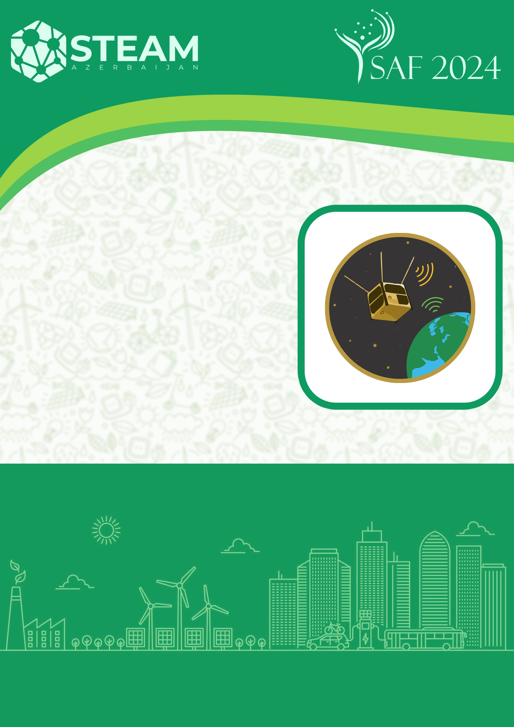

**SELECTION PHASE PRESENTATION**

**BAKI 2024**

**CubeSat**

**CATEGORY**

**Team name:**

**Name, number and address of the school:**

**Team leader:**

**1st student:**

**2nd student:**

1. About CubeSat

*(Explain the advantages of the elements used in the model made here, the work they do, the design of the CubeSat, its dimensions, weight, etc.)*

1. Wireless communication with the CubeSat

*(There should be a video of the model made here sending data via wireless connection. The video link should be placed here in YouTube format for 60-90 seconds)*

1. Team photo

*(Here, all team members must have a photo at work or in front of the drone)*

1. Technical name and pictures of the elements used
   1. Sensors (names and pictures)

*(If more than 1 sensor is used here, the name and picture of each should be mentioned separately)*

* 1. Main controller (name and image)
  2. Wireless connection in use (name and image)
  3. Design of the CubeSat-body element (image in the design program)

1. CubeSat photo images

*(Here, each photo should show the size with a ruler next to the model)*

* 1. From the left
  2. From the right
  3. From the front
  4. From behind
  5. From above
  6. From below

1. Photo images of the Satellite Model
   1. From the front
   2. From above