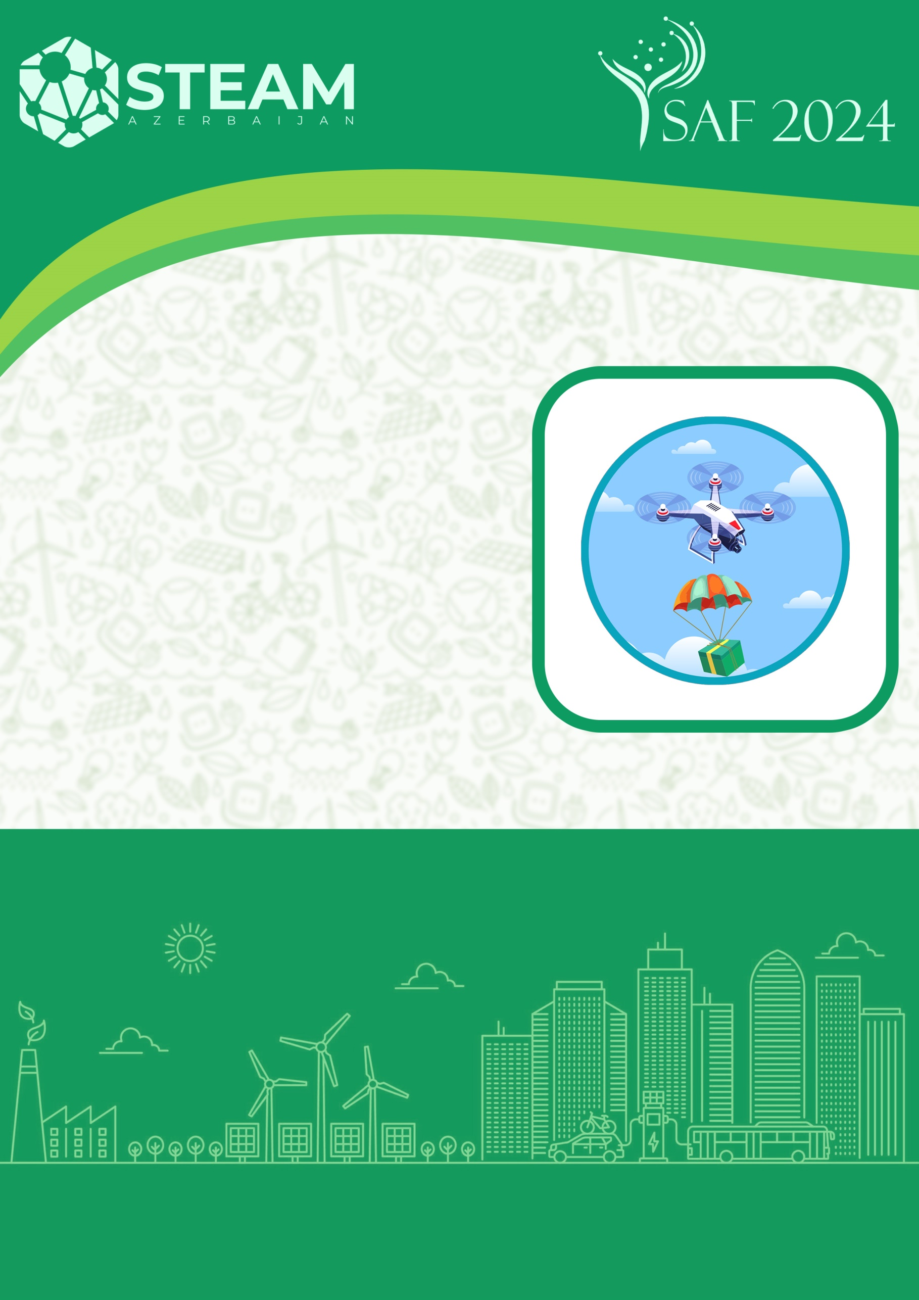

**FlyTech**

**CATEGORY**

**PRESENTATION OF THE SELECTION STAGE**

**BAKI 2024**

**Name of the team:   
  
  
Name, number and address of the school:**

**Team leader:**

**Member 1:**

**Member 2:**

**Member 3: (if applicable)**

1. The peculiarity of the drone

*(Here, explain the advantages of the drone you have made, the body materials used, dimensions, weight, etc.)*

1. Link to drone flight video

*(must be video in Youtube format here)*

1. Team photo

*(Here, all team members must have a photo at work or in front of the drone)*

1. Technical name and pictures of the elements used
   1. Motor (name and picture)
   2. Propeller (name and photo)
   3. Electronic Speed Controller - ESC (name and picture)
   4. Battery (name and picture)
   5. Flight controller (name and photo)
   6. Wireless remote control (name and photo)
   7. Servo motor (name and picture)
   8. Camera (name and photo)
2. Pictures of the drone
   1. From the left
   2. From the right
   3. From the front
   4. From behind
   5. From above